DRYING FOOD
Drying is a traditional method of preserving food and useful when freezer space is limited. It can be very cheap and easy to do. Here are three examples of home dried food.

Borlotti Beans

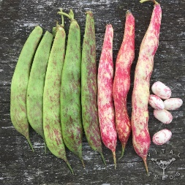
Borlotti beans are grown identically to runner beans, and can be eaten in the same way. However, they can also be grown for the bean itself. If you are growing both runner beans and borlottis, you will recognise the borlottis as the pods have red streaks on them. As they mature, they will lose their green colour, and gradually become brown. If possible, leave them to dry on the plant but, if the weather turns, the pods can be brought indoors. Once the pod is dried, remove the beans and lay them in a tray to continue drying. Once fully dry, store in a glass jar.

Prior to using, soak the beans overnight in cold water then boil rapidly for about 30 minutes. They are now ready for your recipe. They are great added to soups and stews and can also be used in many vegetarian dishes such as veggie moussaka. They will keep for about a year, but will get tougher with age.

Apple slices

These apple slices were dried in a fruit dryer, but it can also be done in an oven. Lakeland sell a domestic dryer for about £55. The apple is peeled and sliced, placed in the dryer and then just left for about 6 hours (but check regularly). Once dried, store in a glass jar. Eat as a snack, add to breakfast cereals or use in recipes.

Herbs

Leafy herbs such as basil and parsley are very easy to dry. Just hang them upside down somewhere warm and dry – an airing cupboard is ideal. Once the leaves are dry, scrunch them up and store in glass jars.

